Task overview
Problem statement
The unstructured execution of a standard Software Requirement Specification (SRS) document makes its automatic analysis extremely difficult. When all of the SRS documents are integrated, this method of requirement analysis is time-consuming, error-prone, and does not support scale.
Objective
The objective of this task is to design and implement an automated pipeline that:
- Extracts text from SRS PDFs
- Segments SRS documents into logical sections
- Extracts functional requirements
- Identifies software features
- Stores all extracted knowledge in a structured database

System scope
In Scope
- PDF-based SRS documents
- Functional and non-functional requirement extraction
- Feature categorization
- Multi-document storage using SQLite
Out of Scope
- Requirement validation
- Requirement prioritization
- Full LLM-based reasoning (future work)
System Architecture
Technology Stack
Component | Technology
Language | Python 3
NLP | NLTK
Database | SQLite
Storage | Relational DB
Tools | DB Browser for SQLite
OS | Windows
Table 1: Technology Stack

Database Design
Database Schema Overview
Documents
Field | Description
document_id | Primary Key
file_name | SRS file name
created_at | Timestamp
Table 2:Document table
Sections
Field | Descriptions
section_id | Primary Key
document_id | Foreign Key
section_name | Section title
section_text | Section content
Table 3: Sections Table
Requirements
Field | Descriptions
requirement_id | Primary key
section_id | Foreign key
requirement_id | Extracted requirements
Table 4: Requirements table
Features
Field | Descriptions
feature_id | Primary key
requirement_id | Foreign key
feature_name | Identify feature
Table 5: Feature Table
Text Extraction Module
- Input: SRS PDF
- Output: Raw extracted text
- Purpose: Converts unstructured PDF into machine-readable text
SRS Section Segmentation Module
- Identifies standard SRS headings (Introduction, Functional Requirements, etc.)
- Uses regex-based pattern matching
- Saves segmented sections into database
Requirement Extraction Module
- Tokenizes functional requirements
- Extracts sentences following IEEE SRS standards
- Filters requirement-like statements (“shall”)
Feature Extraction Module
- Maps requirements to software features
- Uses rule-based keyword classification
- Supports one-to-many mapping
Database Integration Module
- Stores extracted knowledge persistently
- Enables querying and reuse
- Prevents output folder overload

End to end Pipeline execution
The complete SRS processing pipeline is executed using a single command:
“python src/main.py”
This command initiates an automated end-to-end workflow designed to process Software Requirement Specification (SRS) documents efficiently and reliably.
Upon execution, the system performs the following sequential operations:
- Document Registration
The uploaded SRS document is first registered within the system. Metadata such as the document name and a unique document identifier are generated and stored in the database. This ensures traceability and enables future retrieval or reprocessing of the document.
- Section Segmentation and Storage
The content of the SRS document is extracted and segmented into logical sections based on standard SRS structure. Each identified section is then stored in the database, preserving the original document hierarchy for structured analysis.
- Requirement Extraction
The segmented sections are analyzed to automatically identify and extract functional and non-functional requirements. This step transforms unstructured textual content into structured requirement entities that can be further processed.
- Feature Mapping
The extracted requirements are mapped to corresponding system features. This mapping establishes a clear relationship between requirements and potential implementation components, supporting traceability and design alignment.
- Data Persistence
All generated data—including document metadata, sections, extracted requirements, and mapped features—are persistently stored in an SQLite database. This ensures data consistency, reliability, and accessibility for downstream processes such as querying, analysis, or integration with other systems.
Overall, this single-command execution demonstrates a fully automated and scalable pipeline that converts raw SRS documents into structured, actionable data, reducing manual effort and improving accuracy in requirement analysis.
Results and Observations
- Successfully extracted 18 functional requirements
- Generated 62 feature mappings
- System supports multiple SRS documents
- Database ensures scalability and traceability
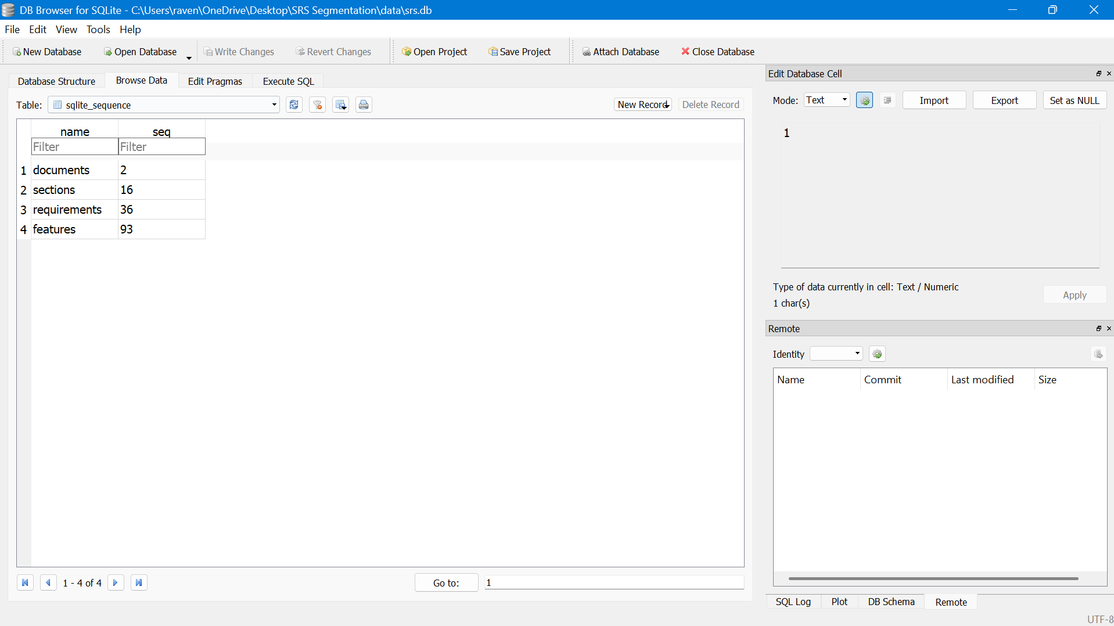
Figure 1: sqlite_sequence
Limitations
- Rule-based feature extraction
- No semantic similarity matching yet
- Language-specific (English SRS)
Future Enhancements
This section is GOLD for mentors 👇
- Integrate LLM + RAG for intelligent querying
- Use vector embeddings for semantic search
- Add requirement prioritization
- Support multiple document formats
- Build a dashboard for analytics
Conclusion
The present task offers a successful illustration of how to split software requirements and extract software features in a software development environment using an automated, scalable, and methodical approach. The platform provides the foundation for intelligent systems to be taught on these needs and utilised for upcoming AI-based requirement analysis by connecting unstructured requirements documents with structured knowledge bases.

Figure 2: Database successfully initialized
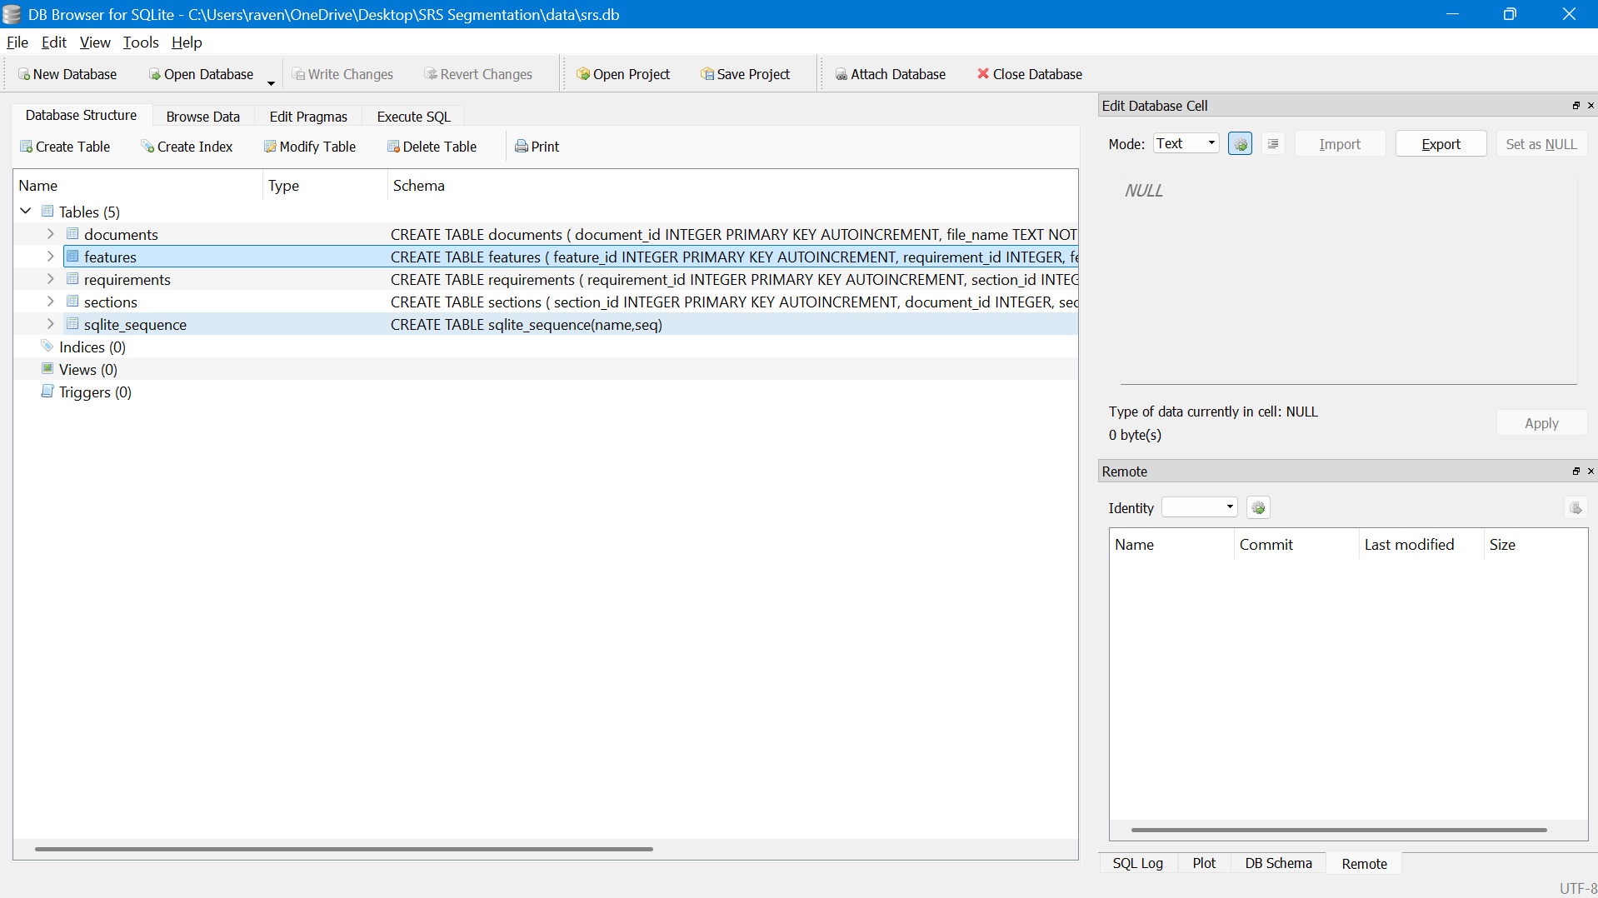
Figure 3: Created database in SQLite
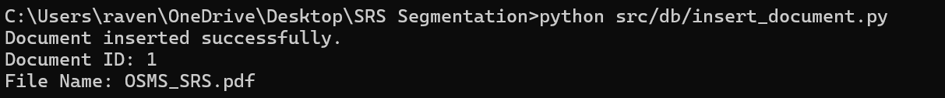
Figure 4: Document inserted into the database

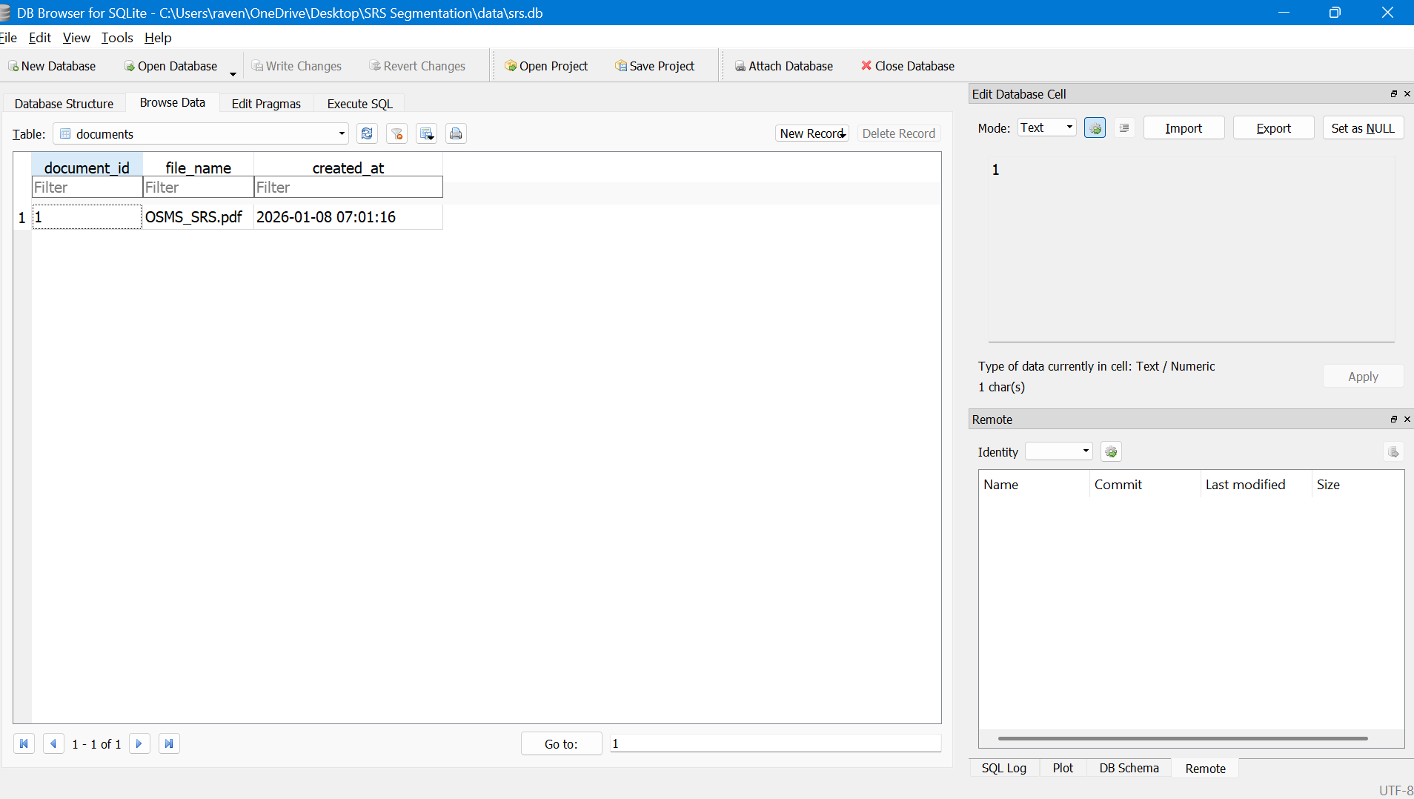
Figure 5: Evidence of document being inserted into the database

Figure 6: SRS section being inserted
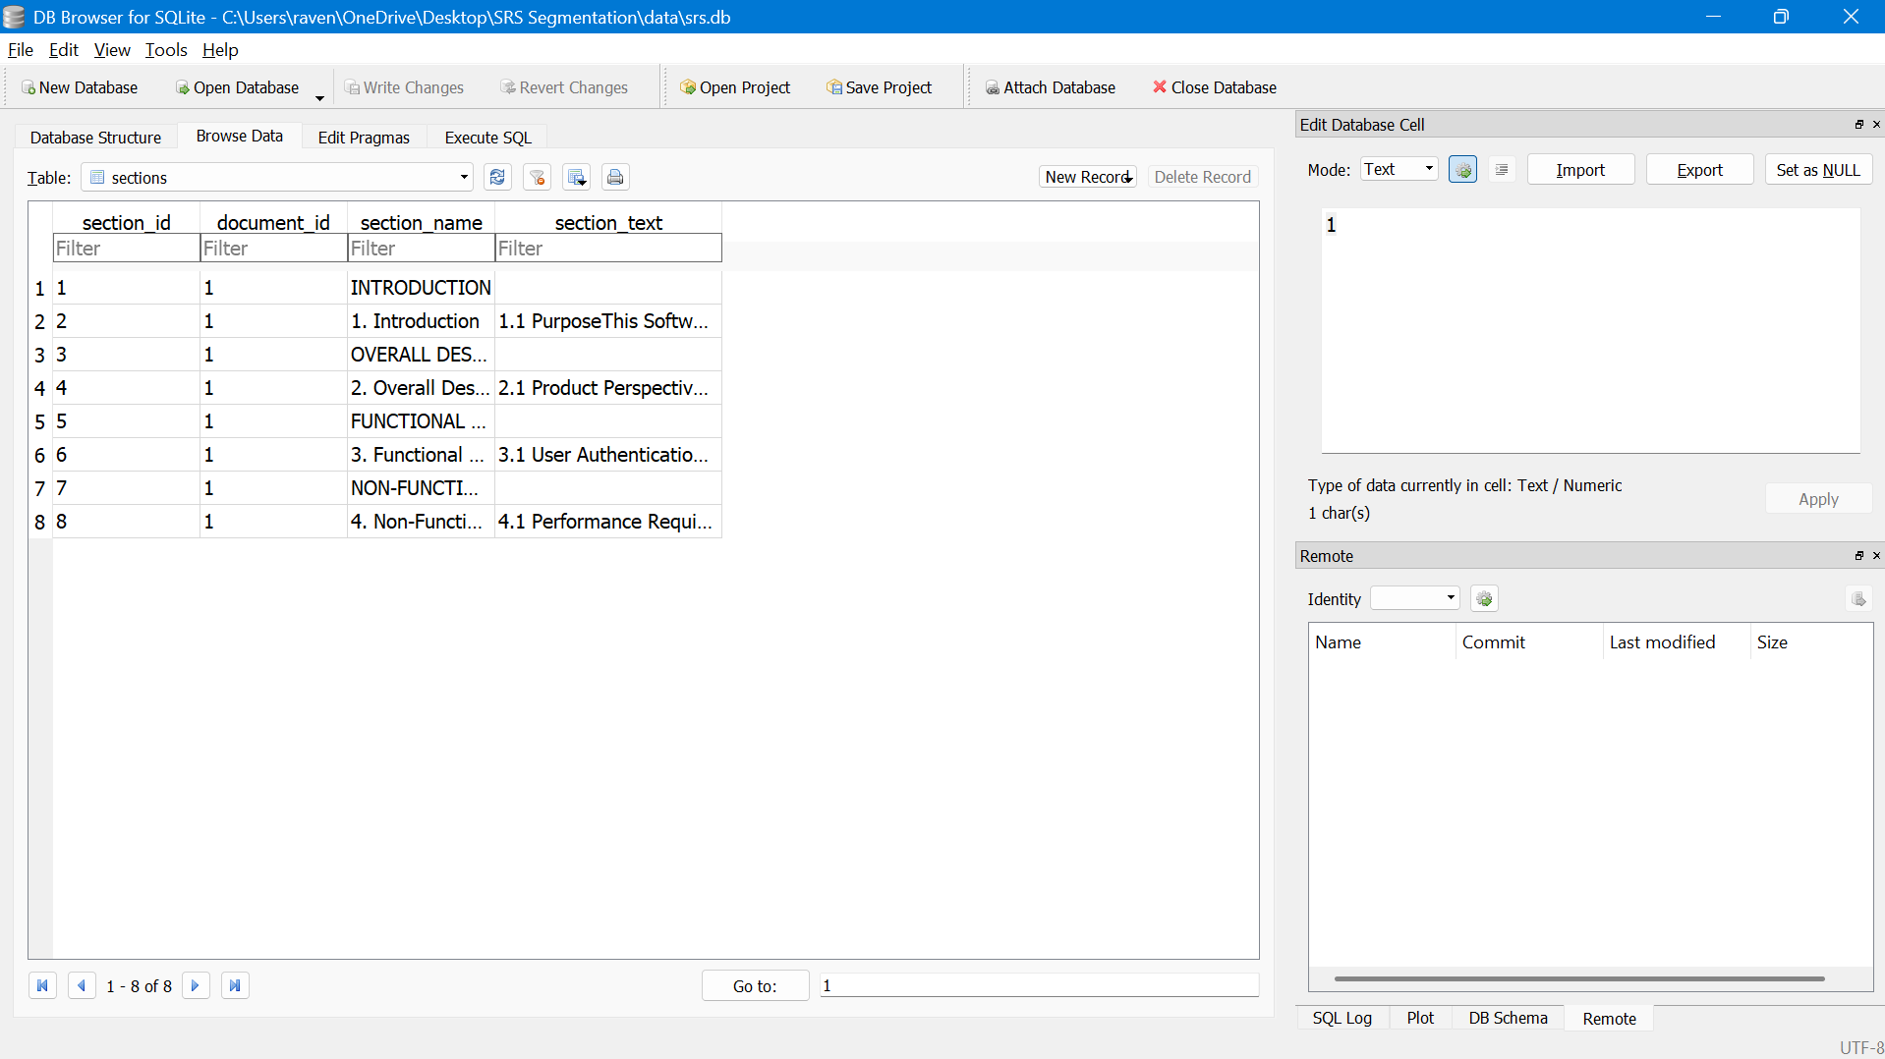
Figure 7: SRS Sections in database

Figure 8: Requirements inserted
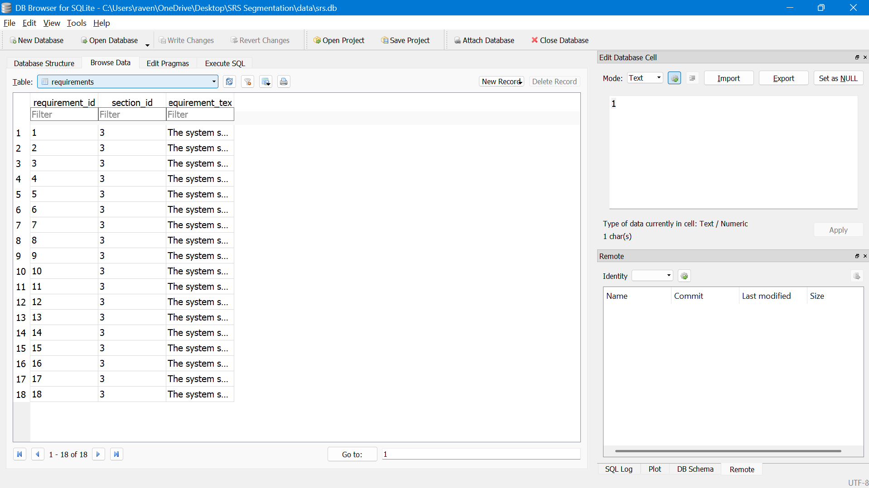
Figure 9: 18 Requirements being inserted
Figure 10: Feature Mappings inserted
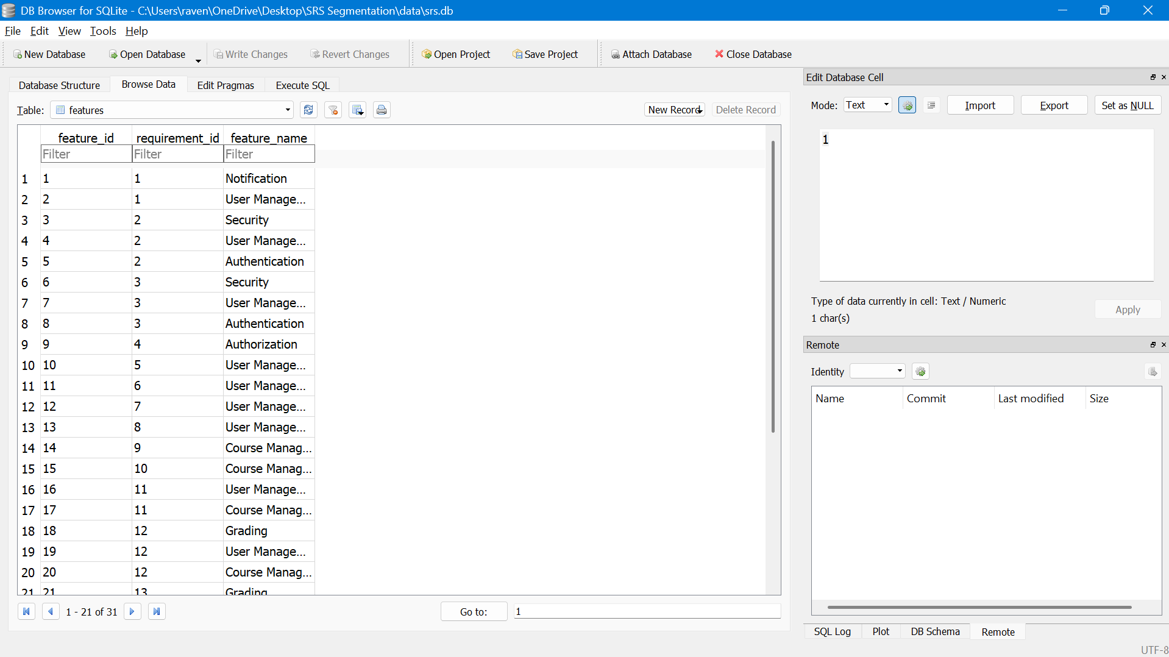
Figure 11: 31 Features being inserted

